# **Project 1**

# **Mountain Dice Game**

CIS-05 42375

Name: Roybal, Lisa

Date: 4/22/2018

## Introduction

This is a dice game. The object of the game is to climb the mountain, in number order, and then descend the other side.

The dice game is fairly straight forwarded. I added a soft, medium, and hard throw to spice up the mechanics a little bit. The hardest part was getting the mountain to print properly.

## Summary

Project size: 130+ lines

Number of variables: about 15

## Psuedocode

Initialize

Player enters number

If player enters valid strength

Roll dice strength number of times

If final dice roll equals next position to move to

Move to that position

If position is final spot print win message

Else

Print actions performed

Print Mountain with position

Else

Exit Game

## Flowchart

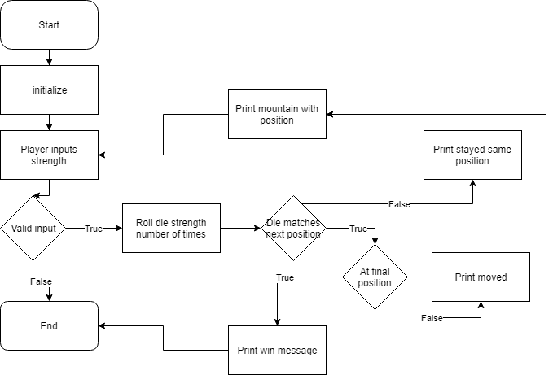

|  |  |  |  |  |  |
| --- | --- | --- | --- | --- | --- |
| Chapter | Section | Topic | Where Line #''s | Pts | Notes |
| 2 | 2 | cout | 49, etc. |  |  |
|  | 3 | libraries | 8-10 | 8 | Iostream |
|  | 4 | variables/literals | 29 |  | No variables in global area, failed project! |
|  | 5 | Identifiers | 29,etc. |  |  |
|  | 6 | Integers | 29-32,121,etc. | 3 |  |
|  | 7 | Characters |  | 3 |  |
|  | 8 | Strings | 45,46,87,etc | 3 |  |
|  | 9 | Floats No Doubles |  | 3 | Using doubles will fail the project, floats OK! |
|  | 10 | Bools | 33,34 | 4 |  |
|  | 11 | Sizeof ***** |  |  |  |
|  | 12 | Variables 7 characters or less |  |  | All variables <= 7 characters |
|  | 13 | Scope ***** No Global Variables | 17, 18 |  |  |
|  | 14 | Arithmetic operators | 37, 52, etc. |  |  |
|  | 15 | Comments 20%+ |  | 5 | Model as pseudo code |
|  | 16 | Named Constants | 17-19 |  | All Local, only Conversions/Physics/Math in Global area |
|  | 17 | Programming Style ***** Emulate |  |  | Emulate style in book/in class repositiory |
|  |  |  |  |  |  |
| 3 | 1 | cin | 51 |  |  |
|  | 2 | Math Expression | 57,etc. |  |  |
|  | 3 | Mixing data types **** |  |  |  |
|  | 4 | Overflow/Underflow **** |  |  |  |
|  | 5 | Type Casting | 44 | 4 |  |
|  | 6 | Multiple assignment ***** |  |  |  |
|  | 7 | Formatting output |  | 4 |  |
|  | 8 | Strings | 49,etc. | 3 |  |
|  | 9 | Math Library | 8 (rand) | 4 | All libraries included have to be used |
|  | 10 | Hand tracing ****** |  |  |  |
|  |  |  |  |  |  |
| 4 | 1 | Relational Operators | 125,etc. |  |  |
|  | 2 | if | 125,etc | 4 | Independent if |
|  | 4 | If-else | 128 | 4 |  |
|  | 5 | Nesting | 125-133 | 4 |  |
|  | 6 | If-else-if | 125-133 | 4 |  |
|  | 7 | Flags ***** |  |  |  |
|  | 8 | Logical operators | 123 | 4 |  |
|  | 11 | Validating user input | 69 | 4 |  |
|  | 13 | Conditional Operator | 93 | 4 |  |
|  | 14 | Switch | 54 | 4 |  |
|  |  |  |  |  |  |
| 5 | 1 | Increment/Decrement | 52 | 4 |  |
|  | 2 | While | 47 | 4 |  |
|  | 5 | Do-while |  | 4 |  |
|  | 6 | For loop | 121 | 4 |  |
|  | 11 | Files input/output both | 151-168 | 8 |  |
|  | 12 | No breaks in loops ****** |  |  | Failed Project if included |
|  |  |  |  |  |  |
|  |  |  |  |  |  |
|  |  |  |  |  |  |
|  |  |  |  |  |  |
|  |  |  |  |  |  |
|  |  |  |  |  |  |
|  |  |  |  |  |  |
|  |  |  |  |  |  |